C Pham

surf city software consulting inc. | July 15, 2018

Schedule Tool

Functional Specification

Contents

Client Commission Rates 4

Permissions 4

User Interface 5

Country 5

Client Names 6

Anniversary 6

Tiered 6

Commission Structure 7

View/Edit Rates by Qtr/Week Below: 7

Clear Week Rates 9

Apply Selected Value to all Weeks in Qtr 9

On EXIT 9

Save 9

Updating a Client Commission Rate 10

Deleting a Client Commission Rate 10

Log Export 10

Permissions 10

User Interface 10

Country 11

Client Name 11

Network Name 11

Plan Year Type 11

Plan Year 12

Month 12

Export Log for Invoice Comparison 12

Canadian Exchange Rates 13

Permissions 13

User Interface 14

Plan Year 14

Quarter 14

Client 14

Rate 14

Save 15

Updating a Canadian Exchange Rate 15

Deleting a Canadian Exchange Rate 15

Create New Property 16

Permissions 16

User Interface 18

country 19

Plan Year 19

Quarter 20

Plan Type 20

Network 21

Property Name 21

Combo Property 21

Buy Type 21

Day Part 21

Status 22

Start Time 22

End Time 22

Days 22

Effective Date 22

Expiration Date 23

Demographics 23

SAVE/Update 23

DELETE 24

Manage Media 24

Upfronts 24

Edit 24

VIEW UPFRONT 34

Create Upfront 35

Delete Upfront 35

Display All Upfronts 36

Remnants 36

Edit 36

Appendix A. Permissions (provided by Ocean Media) 40

Appendix B. Schedule 41

# Client Commission Rates

Approved On: 7/15/2018  
Approved By: Brenda Cwierz  
Promised Delivery Date: 7/31/2018  
PUBLISHED: 7/31/2018

## Permissions

As defined by Ocean Media: Limited based on list (Appendix A)

Only allow access to those assigned a “Finance” Role. Icon as shown on Figure 1 will not be visible to those with no “Finance” Role. (Figure 1. Access to Client Commission Rates)

The “Finance” role will be given to:

|  |
| --- |
| * Sean Reagan |
| * Georgina Valdez |
|  |
| * Louis Seper |
| * Stephanie Filipponio |
| * Annmarie Turpin |
| * Brenda Cwierz |
| * John Wraase |
|  |
| * Simon Lu |
| * Carmela Pham * Tathagat Dwivedi * Michael Lee |
|  |

Figure 1. Access to Client Commission Rates

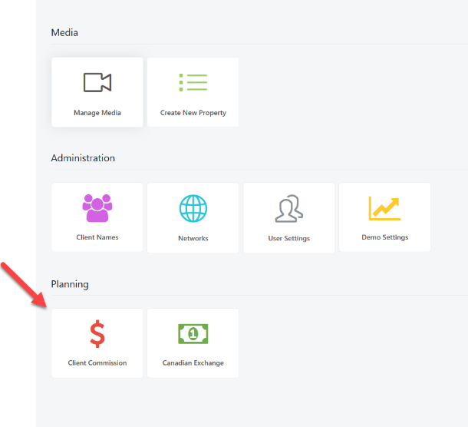

## User Interface

Figure 2. Client Commission Rates

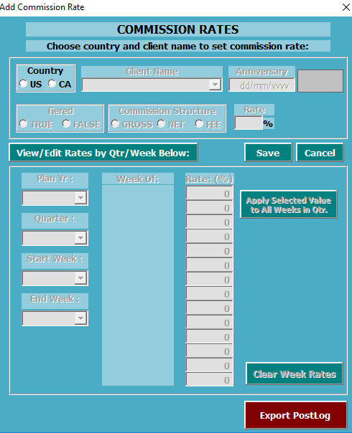

Initial State

All controls in the form will be disabled except for *Country* and *“Export PostLog”* button.

### Country

Initial State

* Only two countries will be displayed US(5) and CA(2).
* No default selection

On Change Selection

Client Name will be enabled and user will be allowed to select a client.

### Client Names

Initial State

* Populate with clients based on country selection.
* If Country selected is CA, append “Canada” to the client name displayed on the drop down.

On Change Selection

Enable and assign values based on client selection:

* Anniversary
* Tiered
* Commission Structure
* “View/Edit Rates by Quarter/Week Below:”

Other Notes

* (Brenda 7/25/18) Remove message “Rate varies by Qtr/Week. See below” (Figure 3)
* (Carmela 7/31/18) “VARIES PER QUARTER” is displayed in the rate text box to indicate that there is no standard rate for the selected client.

Figure 3. Client Commission (Upon client selection action on Rate)

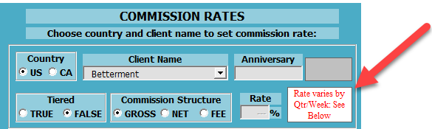

### Anniversary

Initial State

* Load from CLIENT_T table

On Edit

* Date format validation

### Tiered

Initial State

* Load from CLIENT_T table

On Change Selection

* No Action

### Commission Structure

Initial State

* Load from CLIENT_T table

On Change Selection

Warn user that all rates will be permanently delete from database. If fee is selected, set rate to zero and do not allow user to edit rates as all will be set to zero too.

### View/Edit Rates by Qtr/Week Below:

#### Gross and Commission Structure Radio Buttons selected

Initial State (Figure 4. View/Edit Rates by Qtr/Week)

* “Plan Year” dropdown active
* “Clear Week Rates” active
* All else inactive.

Figure 4. View/Edit Rates by Qtr/Week

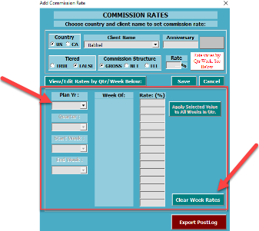

**Plan Year**

Initial State

* None Selected
* Plan Year drop down populated from 2017 forward

On Change Selection

* Enable Quarter
* Populate Quarter dropdown
* Disable “Clear Week Rates”

**Quarter**

Initial State

None Selected

On Change Selection (Figure 5. On Change Quarter)

* Enable Start Week
* Enable End Week
* Fill weeks and rates for week
* Enable “Apply selected value to all weeks in Qtr”
* Enable “Clear Week Rates”

Figure 5. On Change Quarter

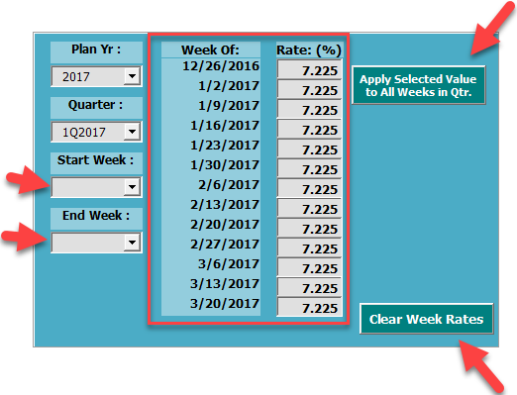

**Start Week**

Initial State

* Empty but populated with week values for the selected quarter.

On Change Selection

* Select End Week to the last in the selection
* Disable/enable rates and dates depending on start/End Week selection (Figure 6. Rate status based on Start/End Week selections).
* Update End Week so that it only contains dates after “Start Week”

Other Notes

* **Per Brenda, Figure 6 is a bug. 3/12 and 3/19 should be disabled in this case. The general rule is that only dates between start and end week should be enabled.**
* **After I clicked saved, I was told it was saved successfully and then it was followed by an alert that states “1/29/2018 should not be left blank.” Intentional?**

Figure 6. Rate status based on Start/End Week selections

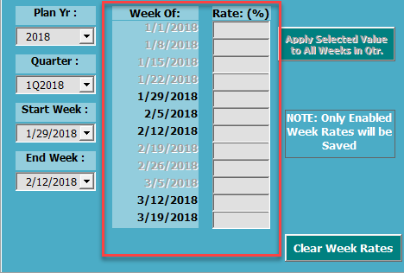

**End Week**

Initial State

* No selection until “Start Week” is set.
* All selections are dates AFTER selected “Start Week”

On Change Selection

* Enable/Disable rates accordingly
* (Brenda 7/25/18) Hide any week that is not being used.

**Columns Week and Rate %**

Initial State

* + Enable/Disable based on Start/End Week

### Clear Week Rates

Empty all selected weeks for commission/rate as in Figure 4. View/Edit Rates by Qtr/Week

### Apply Selected Value to all Weeks in Qtr

Provide a text box where user can enter the rate to apply to all selected dates.

### On EXIT

Prompt to SAVE before leaving page if there were any changes to the settings

## Save

Actions taken:

1. Validate a country is selected.
2. Validate client is selected
3. Validate Commission Structure is selected.
4. There is a check for commission rate entry but there never seems to be a time this is enabled for user entry.
5. Validate Weekly Rates
6. Save Client Commission Rate and Related Attributes
7. Reload information into the user interface so user can view.

## Updating a Client Commission Rate

* User can edit a client commission rate based on selection of Plan Year, Quarter, Start Week, End Week. If the correct combination is selected, it is loaded into the dialog.

## Deleting a Client Commission Rate

* Not applicable

# Log Export

Approved On: 7/26/2018  
Approved By: Brenda Cwierz  
Promised Delivery Date: 8/30/2018

Figure 7. Log Export Dialog

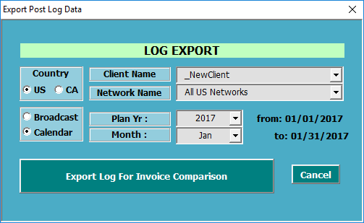

## Permissions

Screen is only accessible from Client Commission Rates dialog. Only accessible to those assigned a “Finance” Role.

## User Interface

(Brenda 7/26/18)

1. Allow user to run both Broadcast and Calendar month report- you will need to user calendar week vs broadcast week dates
2. If no data is available, alert the user that the client and date ranges do not have post log data available.  ( there is currently an alert on Calendar that says NO Matches Found)
3. Otherwise, data will be exported as expected.

### Country

Initial State

* Populate with US, CA
* Default US

On Change Selection

* Populate with Client with Canadian Clients
* Populate Network with Canadian Networks

### Client Name

Initial State

* Populate with US Clients
* Default to first US Client on list

### Network Name

Initial State

* Populate with US Networks and insert first selection as “All US Networks”
* Default to “ALL US Networks”

### Plan Year Type

Initial State

* Populate with Broadcast and Calendar
* Default to Calendar.

On Change Selection

* Update display of “from” and “to” dates based on plan year type, plan year and month

Brenda 7/25/2018 Confirmation from finance that they would like both calendar and broadcast as an option.

### Plan Year

Initial State

* Populate with available plan years. This looks at UPFRONT_T, SCHED_T, POSTLOG_T for unique plan years used.

On Change Selection

* When Broadcast Plan Year Type and plan year is changed, this currently ALWAYS displays an error. Please advise how this should be handled.  
  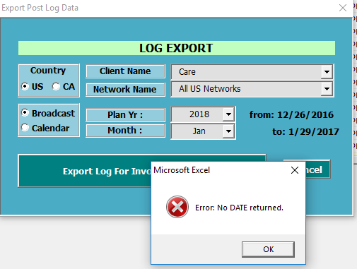

### Month

Initial State

* Populate with January to December

On Change Selection

* Update display of “from” and “to” dates based on plan year type, plan year and month

### Export Log for Invoice Comparison

Export to Excel

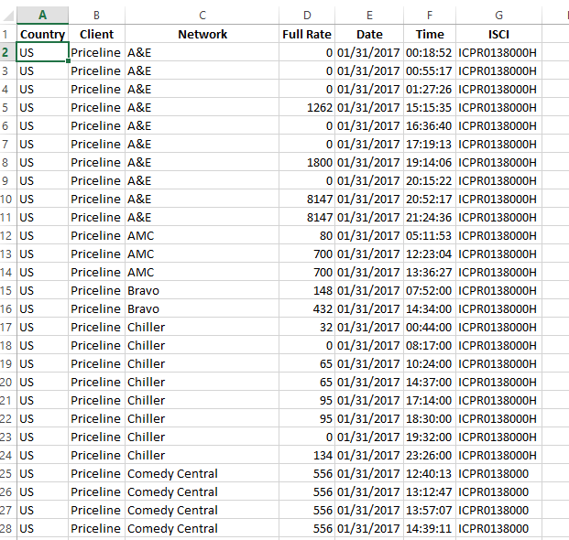

# Canadian Exchange Rates

Approved On:  
Approved By:  
Promised Delivery Date: 7/31/2018

PUBLISHED: 7/31/2018

## Permissions

"Update Actual Exchange Rates" are based on individual permissions to this feature.  In the Excel SchedTool, for example it looks for users in ACTUAL_EXCHANGE_RATE_ADMINS_T.  
  
"Update Client Specific Exchange Rates" are accessible to Admins Only.

Do not show icon on Figure 8. Main Screen Canadian Exchange if logged on user is not an Admin.

Figure 8. Main Screen Canadian Exchange

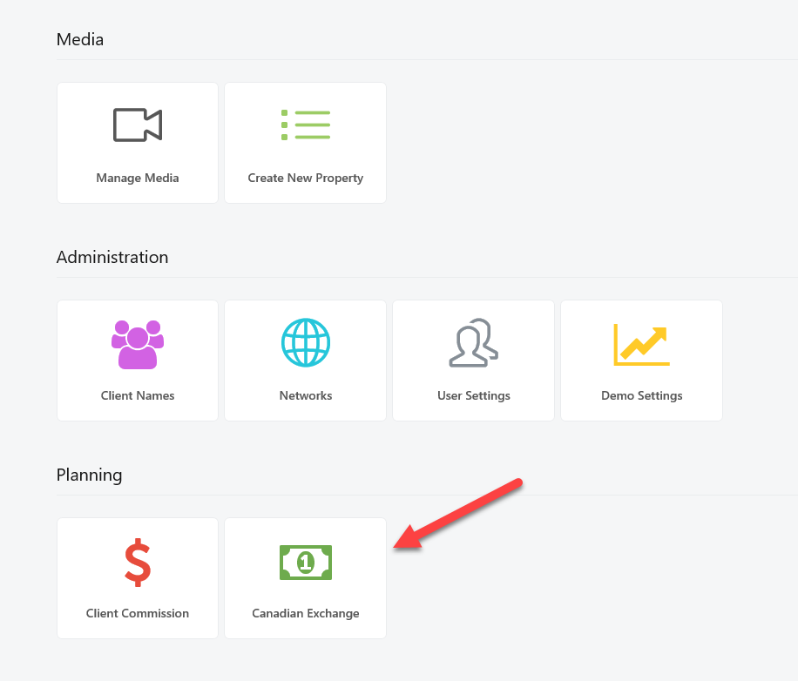

## User Interface

Figure 9. Canadian Exchange Rate Dialog

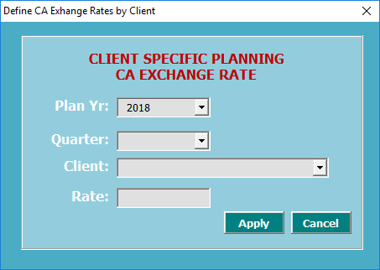

### Plan Year

Initial State

* Populate all plan years in existing quarters (QTR_T). Broadcast Year is the only one actually used.

On Change Selection

* Get all unique quarters for the plan year. This is always Broadcast Year

### Quarter

Initial State

* Get all unique quarters for the plan year. This is always Broadcast Year.

On Change Selection

* No action. Current code reloads all clients for CA when quarter selection is changed. However, we will skip this. This is not necessary
* Repopulate Client List

### Client

Initial State

* Get all clients for CA

On Change Selection

* No action

### Rate

Initial State

* Blank

## Save

1. Save to database
   1. If there is no entry for the Client/Quarter pair in the database, create a new entry.
   2. If there are entries and the count for the client quarter weeks is between 12 and 14
      1. Update rate for all weeks to the user-entered rate where actualized =0
      2. update planning rates for all weeks to the user-entered rate
   3. if there are entries but entry count is less than 12, rollback. We cannot update this client/quarter.
2. Clear form for next entry

## Updating a Canadian Exchange Rate (CA Exchange Rate Actuals)

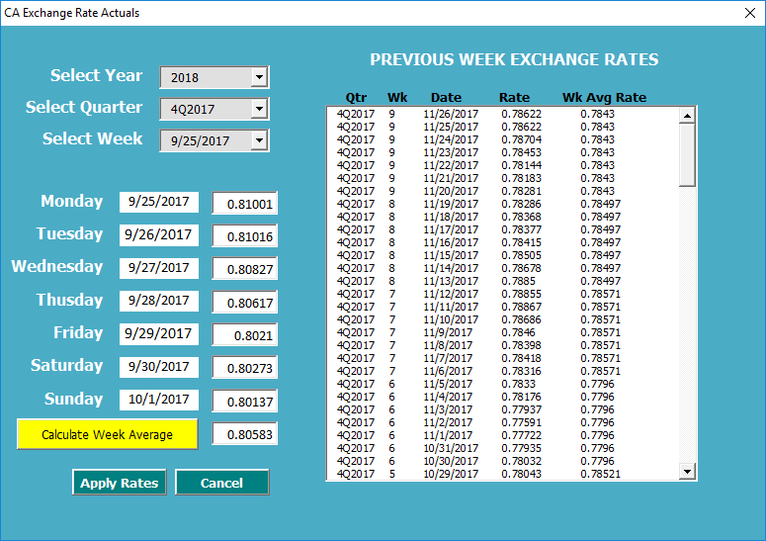

InitlaizeState

* All fields are empty
* Year – Populated

### Year

Initial State

* Populated with years starting from 2017 (Configurable in config file)

On Change Selection

* Populate Quarter

### Quarter

Initial State

* Populate based on year selection

On Change Selection

* Populate Weeks
* Populate historical data

### Week

Initial State

* Populate based on quarter selection

On Change Selection

* Calculate exchange rate for each day of week selected
* Calculate average exchange rate for the week selected

### Calculate Week Average (Button)

Calculate average of daily exchange rate for the selected week.

### Apply Rates (Button)

* Save changes in daily rates to the database
* Reload historical data

## Deleting a Canadian Exchange Rate

* Not applicable

# Create New Property

Approved On: 7/25/2018  
Approved By: Brenda Cwierz  
Promised Delivery Date:

* 7/31/2018 (Only from Main Screen)
* 8/31/2018 (from Upfront/Remnant View)

## Permissions

Accessible only to LOW, MEDIUM, ADMIN users. GENERAL Users do not have access.

There are three ways to access Create New Property:

First is through the main screen. (Figure 10. Accessing Create New Property from the Main Screen.) General Users will not see this icon on the main screen.

Second is through the Remnant Window (Figure 11. Accessing “Create New Property” from Remnant Screen). This button should not be visible to General Users.

Third is through the Upfront Window (Figure 12. Accessing "Create New Property" from Upfront Screen). This button should not be visible to General Users.

NOTE: From the remnant and upfront windows, the “Create New Property” dialog will be pre-populated with information. This will be discussed in detail later.

Figure 10. Accessing Create New Property from the Main Screen.

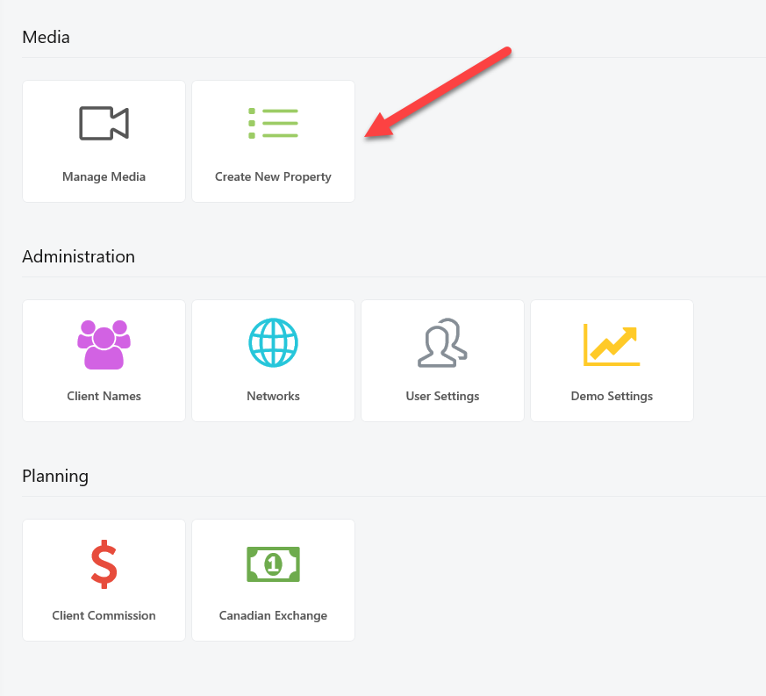

Figure 11. Accessing “Create New Property” from Remnant Screen

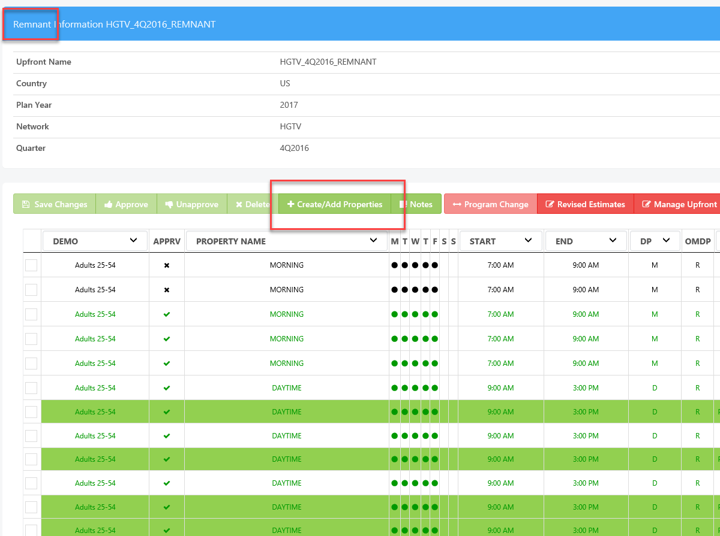

Figure 12. Accessing "Create New Property" from Upfront Screen

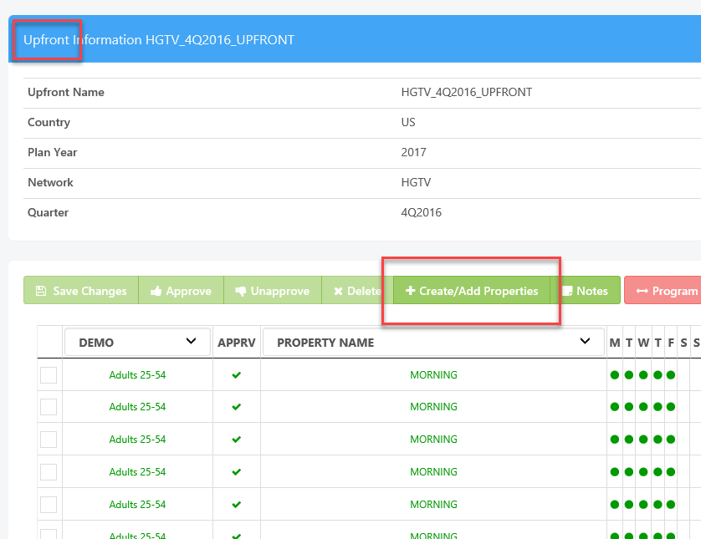

## User Interface

Figure 13. Create New Property

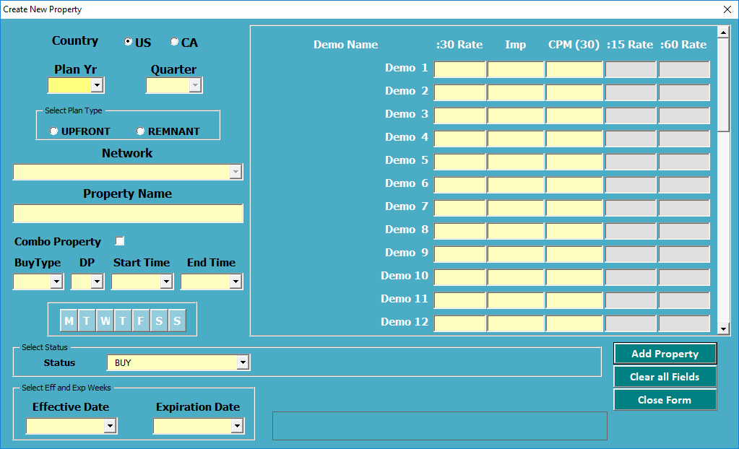

### country

Initial State

* Populate with user’s country associations.
  + If both, select US.
  + If only US, select US.
  + In only CA, select CA

### Plan Year

Initial State (from Main Screen)

* Populate with unique plan years
* No default value

Initial State (from Upfront/Remnant View)

* Populate with year from current upfront/remnant

On Change Selection (from Main Screen)

* Populate Quarter
* Populate Networks
* Default to Status to BUY.

(Brenda 7/25/18) For the sake of clarity, we can change the attribute of DoNotBuyType to Status

On Change Selection (from Upfront/Remnant View)

* Changing selection is not an option.

### Quarter

Initial State (from Main Screen)

* Not populated
* Disabled

Initial State (from Upfront/Remnant View)

* Populated only with quarter used by current Upfront/Remnant

On Change Selection (from Main Screen)

* Populate Effective Dates based on Quarter
* Populate Expiration Dates based on Quarter
* Populate Demo Names based on Quarter and Country

On Change Selection (from Upfront/Remnant View)

* Changing selection is not an option

### Plan Type

Initial State (from Main Screen)

* Populate with Upfront and Remnant
* None selected by default

Initial State (from Upfront/Remnant View)

* Only enable Upfront if Upfront is currently selected.
* Only enable Remnant if Remnants is currently selected.

On Change Selection (from Main Screen)

* No effect

On Change Selection (from Upfront/Remnant View)

* Changing selection is not an option

### Network

Initial State (from Main Screen)

* Not populated
* Disabled

Initial State (from Upfront/Remnant View)

* Populated only with network used by current upfront/remnant.

On Change Selection (from Main Screen)

* Populate Buy Type based upfront type (upfront or remnant)

On Change Selection (from Upfront/Remnant View)

* Changing selection is not an option.

### Property Name

Initial State

* Not populated
* Enabled

### Combo Property

Hide this control but do not remove from application.

### Buy Type

Initial State (from Main Screen)

* Not populated
* Enabled

On Change Selection

### Day Part

Initial State

* Populate with existing day parts
* No default

### Status

Initial State

* Populate with Do Not Buy Types
* Default is BUY

On Change Selection

* If “Client Mandate” or “Client Specific”, allow user to select client. Set default client based on country

### Start Time

Initial State (from Main Screen)

* Prepopulated with 30 minute increments
* Enabled

On Change Selection

* Change default End Time selection to next 30 minutes once focus goes to the control.

### End Time

Initial State

* Prepopulated with 30 minute increments
* Enabled

### Days

Initial State

* M-T-W-Th-F-S-S
* All not selected
* All Enabled

### Effective Date

Initial State (from Main Screen)

* Not populated
* Enabled

Initial State (from Upfront/Remnant View)

* Because quarter is already selected, we fill up effective dates and expiration dates with the same values used when quarter selection changes above.
* By default, select the first on the list.

### Expiration Date

Initial State (from Main Screen)

* Not populated
* Enabled

Initial State (from Upfront/Remnant View)

* Because quarter is already selected, we fill up effective dates and expiration dates with the same values used when quarter selection changes above.
* By default, select the last on the list.

### Demographics

* Rates are numeric entry only
* If Buy Type is zero rate type, then rate should always be zero
* Update :15 and :60 from :30 and Impression
* IF :30 blank so should :15 and :60
* If Buy Type is PE or PDR, duplicate the first demo rate for all remaining demo

## SAVE/Update

1. Validation of fields
2. Check if property exists based on: NetID, QtrName, PropName, DayPart, DaysCode, StartTime, and EndTime. If it doesn’t exist, go to 3 else go to 4
3. Create Property
4. Reference existing property found in #2
5. The property id created in #3 or referenced in #4 will be used to create rates
6. Check each populated demo based on @PropertyId, @DemographicSettingsId, @QuarterId, @BuyTypeId, @DoNotBuyTypeId, @ActualMandateClientId, @Revision. If it already exists, alert user and go to 15.
7. Add Spot Len 30, 60 , 120 to rates
8. Add Spot Len 15 based on US and CA rules for splitting
9. If Buy Type in BUY_TYPE_T has IsAddADU as 1 then, Add ADU rates (15, 30, 60, 120). Spot Len 15 uses US and CA rules for splitting.
10. Auto-approve new rates created in 9 if IsAutoApprove for the Buy Type is set to 1.
11. Check if upfront already exists based on UpfrontType, Network, Quarter.
12. IF Upfront already exists and upfront is locked, rollback all actions taken from Step 1. Do not create upfront.
13. IF Upfront already exists and upfront is not locked, insert new upfront lines based on rates created.
14. If Upfront does not exist, create Upfront unless Upfront is currently locked. Append _UPFRONT or _REMNANT to name accordingly and insert upfront lines based on rates created.
15. End.

Brenda 7/25/18

* StartTime should always be before EndTime

## DELETE

7/10/2018

Not clear on this yet. I believe a property can never be deleted but an upfront/remnant line can. I have not tested code to observe behavior at this point.

07/24/2018

Properties can be deleted from schedules/proposals.

# Manage Media

## Upfronts

Approved On:  
Approved By:  
Delivery Date: 08/31/2018

### Edit

#### Save Changes (NEED JOHN’S HELP IDENTIFYING ALL PLACES IN THE CODE WHERE SAVE IS TESTED AND EXECUTED)

1. Check to see if one or more Approved Lines have changed Property data
2. If there is at least one row with changed Upfront Line Data that is already APPROVED, prompt the User to Continue or Cancel  
   *One or more lines in this Workbook contained changed data AND one or more of these changed lines were already marked as 'Approved'. You chose not to cancel saving any data."*
3. Save any Changes in Non-Approved Lines[1]

Properties (each row) are editable if they meet the following criteria:

* Line is not approved
* Line is not approve locked
* Spot len = 30 (Brenda, need more explanation of this rule)
* NetworkId of property is the same as the upfront’s networkid[2]

When a row is edited, change to color of the cell to RED so user knows what was edited.

Only the following columns can be edited

1. Property Name
2. Days Code
3. Start Time
4. End Time
5. Day Part
6. Buy Type
7. Rate
8. Imp
9. Status
10. Client Name
11. Effective Date
12. Expiration Date

#### Create/Add Property

Defined in Create New Property (p. 15)

#### Add/Edit Notes

Current Status: Ready for Dev QA based on approved spec.

##### Create (Add Note)

Note can be created by typing the note on the edit box provided (see Figure 14. Create Note) and clicking save.

Upon clicking save, note will be saved to the database and displayed in the list of notes for the upfront (see Figure 14. Create Note)

Figure 14. Create Note

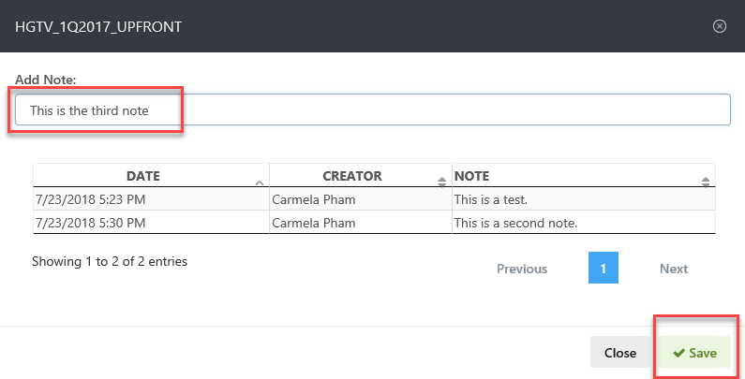

##### Read (Display Notes)

Notes are displayed from Upfront Edit/View Screen (see Figure 14. Create Note) in a paged data table that can be sorted by creation date, note creator and note description.

##### Update

Notes cannot be updated.

##### Delete

Notes cannot be deleted.

#### Delete Property

Current Status: Ready for Dev QA based on approved spec.

User can check all properties that they want to delete and click “Delete” button to delete them.

Before deleting properties selected, they have to be validate. Properties can only be deleted if they meet the following criteria:

1. Property needs to be ADU or A Buy Type
2. Property should be spot len 30
3. Property selected is NOT approved.
4. Check to see if the property is not approvelocked (no related properties approved)
5. For each spotlen 30 selected, all properties with the same buy type, status, demo and property name will be evaluated as a group.  If one or more Properties in a group are found to be Approved or In Use, none of the Properties in that group will be able to be deleted

#### Filter (Multiple Filter SelectioN)

The current implementation for upfronts data table allows for filters (see Figure 15. Current Implementation of Filters for Data Tables) but it needs to be updated so that multiple filters can be selected.[3]

Figure 15. Current Implementation of Filters for Data Tables

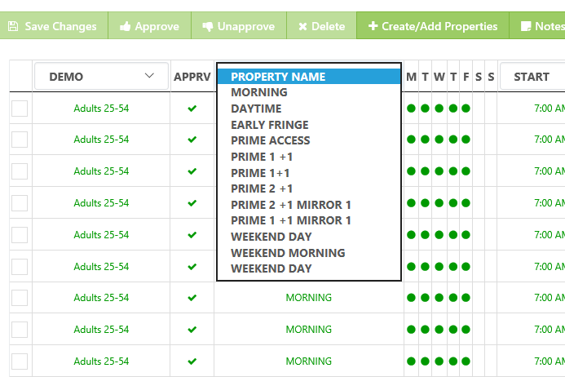

#### Approve

Users can check all upfront lines to be approved and click *Approve* button. The *Approve* button is only enabled for lines that are NOT currently approved.

If SpotLen is 30, 60, or 120, the upfront line is approved (by marking Rate approved).

If SpotLen is 15 (Split), both splits will be approved.

If successfully approved, add transaction to history log of upfront.

If unsuccessfully approved, an alert will be displayed. The following are known reasons for possible approval failure:

1. Unable to update Rate in database. Error message: Upfront Line approval unsuccessful. Unable to update approval status. Please contact administrator.
2. Unable to add to Upfront log history. Error message: Upfront Line approval unsuccessful. Unable to add to Upfront history.

#### Unapprove

Users can check all upfront lines to be unapproved and click *Unapprove* button.

The *Unapprove* button is only enabled for lines that are currently approved.   
The *Unapprove* button is only enabled for upfront lines not in proposals or schedules.

If SpotLen is 30, 60, or 120, the upfront line is unapproved (mark corresponding rate “unapproved”).

If SpotLen is 15 (Split), both splits will be unapproved.

If successfully unapproved, add transaction to history log of upfront.

If unsuccessfully approved, an alert will be displayed. The following are known reasons for possible unapproval failure:

1. Unable to update Rate in database. Error message: *Upfront Line “unapproval” unsuccessful. Unable to update approval status. Please contact administrator.*
2. Unable to add to Upfront log history. Error message: *Upfront Line “unapproval” unsuccessful. Unable to add to Upfront history.*

Brenda,  
When I unapproved a split (spotlen 15), it showed that both split 1 and split 2 will be unapproved (both checkboxes where automatically checked prior to "Unapproving").  However, when I reopened the Unapprove dialog, I saw split 2 is still there.  (Figure 16. Unapprove (Split 1 unapproved but not Split 2)  
  
Is this correct or is this a bug?

Figure 16. Unapprove (Split 1 unapproved but not Split 2)

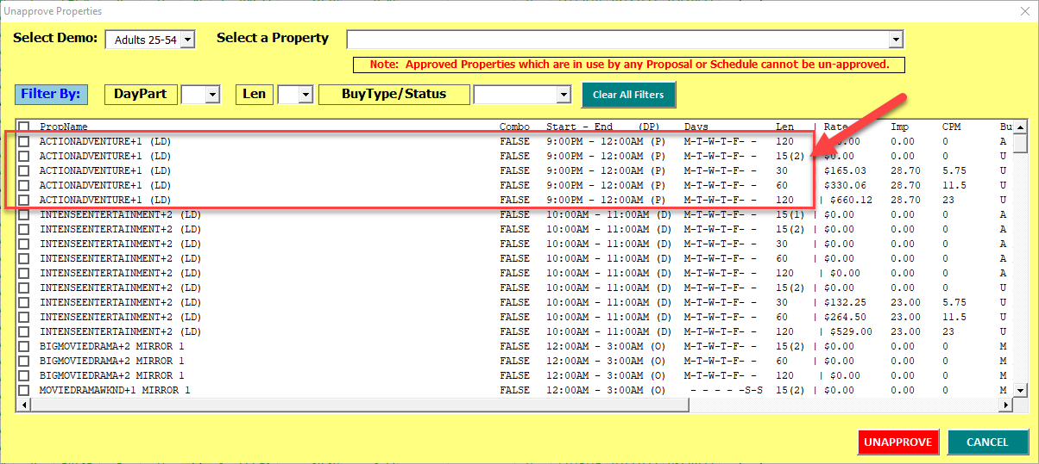

#### Program Change

Program Change will be implemented as a modal dialog[4] (see Figure 17. Program Change)

Figure 17. Program Change

#### 

Initial State

* Populate header with values loaded in upfront: Network, Quarter, Demo, Approved, Do Not Buy
* Populate current program with values from upfront line selected: Property Name, Revision Number, Days Code, Start Time, End Time, DP, BT, Rate, Imp, CPM (Calculated), Effective Date, Expiration Date
* Populate New Property Form Values
  + Name
    - Same as current program
  + Days Code
    - Same as current program
    - Editable
  + Start Time
    - Same as current program
    - Editable
  + End Time
    - Same as current program
    - Editable
  + DP
    - Same as current program
    - Editable
  + BT
    - Same as current program
    - Not editable
  + Rate
    - Same as current program
    - Editable
  + Imp
    - Same as current program
    - Editable
  + CPM
    - Calculated
  + Exp Date
    - Expiration dates for the quarter
    - No default value
    - Editable
  + Eff Date
    - Effective dates for the quarter
    - No Default
    - Editable
  + Exp Date
    - Expiration dates for the quarter
    - Default to the last Monday (or the first Day selected in Days Code)
    - Editable

Change with Auto Approve clicked

1. Validate Form
   1. Property Name is not BLANK (*Please enter a New Program Name)*
   2. Effective Name is not BLANK (*Please select an Effective Date for the new Program)*
   3. Property Name is not the same as the old Property Name (*The new Program Name must different than the existing Program Name*)
   4. Check that EffDate (current date) <= ExpDate
   5. Check that New EffDate > Old EffDate
   6. If the above five are not met, do not continue. Show error message.
2. Verify that there is not an Existing Property Name with same parameters (*A Property with this Name already exists for the current Network and Quarter*). If property name already exists, do not continue.
3. Copy Property to New. If unsuccessful creating new property, do not continue. (*Unable to create a new Property*)
4. Success.

#### Update Deal Point Data

US

1. See Figure 19. Update Deal Point Data -- Upfront/Scatter).
2. If Cancel, go to Step 4.
3. Save.
4. Close all “Update Deal Point Data” modal windows.

Canada

1. Select Media Type. See Figure 18. Update Deal Point Data (Select Media Type for CA)

If National UPFRONT/Scatter, See Figure 19. Update Deal Point Data -- Upfront/Scatter.   
If DR, see

1. Figure 20. Update Deal Point Data -- DR.
2. If Cancel, go to step 5.
3. Save.
4. Close all “Update Deal Point Data” modal windows.

Figure 18. Update Deal Point Data (Select Media Type for CA)

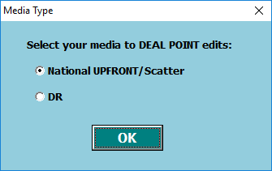

##### Update Deal Point Data – Upfront/Scatter (See Figure 19. Update Deal Point Data -- Upfront/Scatter)

Initial State

* Populate with previously saved settings, if any.

Save

* Save data entered into database.

Figure 19. Update Deal Point Data -- Upfront/Scatter

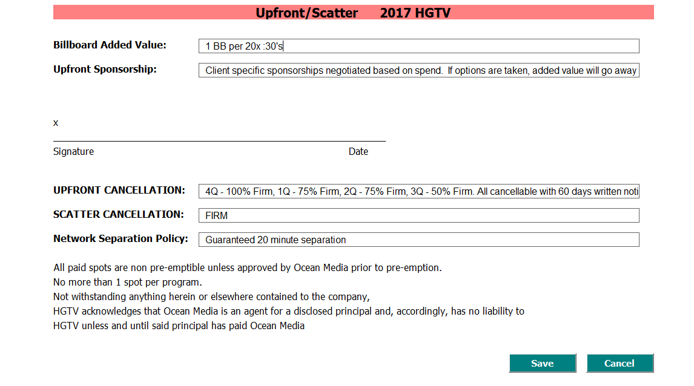

##### Update Deal Point Data – DR (See Figure 20. Update Deal Point Data -- DR)

Initial State

* Populate with previously saved settings, if any.

Save

* Save data entered into database.

Figure 20. Update Deal Point Data -- DR

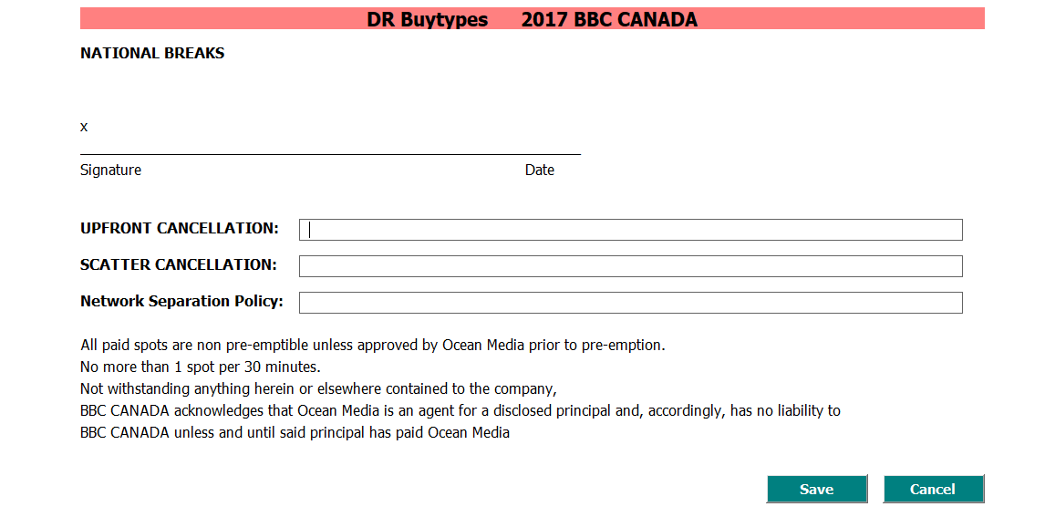

##### Export

When exporting, the following steps are taken to export an upfront:

1. Select Buy Type and Demo (see Figure 21. Export Upfront (Select Buy Types and Demos)
2. Click Export.

##### Export Upfront (Select Buy Types and Demos – Figure 21. Export Upfront (Select Buy Types and Demos))

Figure 21. Export Upfront (Select Buy Types and Demos)

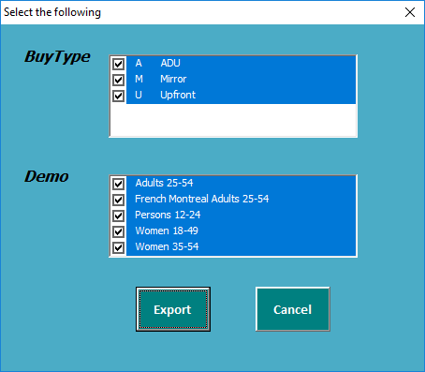

Initial State

* Buy Types – lists all buy types used in the upfront
* Demo – lists all demos used in the upfront

Export Clicked

Based on buy type and demo selection, generate a report with upfront lines as displayed below. User has an option to export the report into Excel by clicking the Excel button. Generated excel is as follows.

#### Permissions

Brenda, can we discuss permissions on your chart again? Thank you.

### VIEW UPFRONT

The code for view upfront is identical with Edit Upfront except that View Upfront is READ-ONLY.

* The data table will not have an editable mode
* The tool bar will be as follows: (Brenda, let’s discuss permissions. I am still able to edit and save in the Excel app)
  + Notes
  + Approve
  + Revised Estimate
  + Auto Approve
  + DR Rate Revision

### Create Upfront

Typically, upfronts are created from “Create New Property” functionality on the home page of the web app. This button on the Manage Media Upfront Screen essentially creates an upfront with no upfront lines.

Initial State

* Initial values are loaded from the active upfront on the media screen

Create Clicked

1. Check that Upfront name is not blank.
2. Verify that the upfront name does not exist for the selected network/quarter.
3. Create Upfront (Add record to Upfront table)

Figure 22. Create Upfront

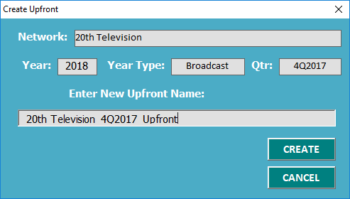

### Delete Upfront

Prompt before deletion.

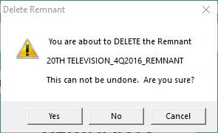

### Display All Upfronts

Delivered.

## Remnants

### Edit

#### SAVE CHANGES

Defined in Save Changes

#### Create/Add Property

Defined in Create New Property

#### Add/Edit Notes

Defined in Add/Edit Notes

#### Delete Property

Defined in Delete Property

#### Filter (Multiple Filter Selection)

Defined in Filter.

#### Approve

Defined in Approve

#### Unapprove

Defined in Unapprove.

#### Program Change

Defined in Program Change

#### Revised EstimatES

Figure 23. Remnants - Revise Estimate

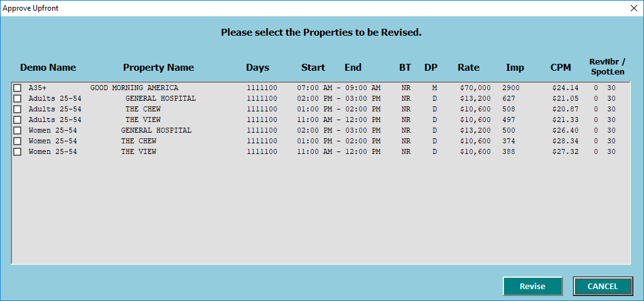

Initial State

* Populate with all Demos/Property Name available in the upfront and allow user to chance to select those they want to revise.

Revise Click

1. Only revise those with Buy Type GR (Guaranteed Remnant), NR (Non-Guaranteed Remnant) or UE.  
   *Error Message: “Can’t be revised because none of Buy Type is Guaranteed Remnant, Non-Guaranteed Remnant or ADU !”*  
   Brenda, this is the current error message displayed but the code checks for UE not A.
2. Check if the current revision has been populated with Rate and IMP  
   *Error Message: “No new revision can be created when the latest revision contains 0 in Rate or Imp!”*
3. Check if there are unsaved property changes.  
   *Error Message: “This remnant has unsaved rate changes. Please save changes before approving.”*
4. Check if approved.  
   *Error Message: “Have to be approved before revision!”*
5. Show confirmation alert to user: “*This will create Revised Estimate for the selected Properties , Continue?”* If no, stop
6. Find largest revision number for property.
7. Create revisions with blank rate (the whole set of varying spot length)
8. Duplicate all properties in remnant lines.
9. Notify user of success:  
   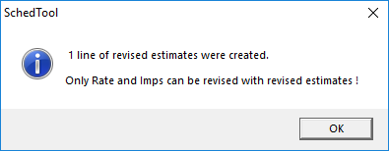

#### Update Deal Point Data

Defined in Update Deal Point Data

#### Auto Approve

“Auto Approve” automatically approves properties with CMP within -0.02 to -0.02. Brenda, I’m not sure if I am correct in my understanding of this. Please advise.

1. Check if by type is GR, NR or UE. If not, show error message (“*Can’t be approved for Buy Type Premium DR and Pre-Emptible DR !”)*
2. Check for unsaved property changes.  
   Error Message: *This Remnant has unsaved rate changes. Please save changes before approving.*
3. Aut0-Approve if CMP within -0.02 to 0.02 of original CMP.
4. Show status: Success or Fail.

#### DR Rate Revision

1. Check for unsaved rate changes.  
   Error Message: *This remnant has unsaved rate changes. Please save changes before approving.*
2. There is a check for unsaved header changes. Can you show me how the header is modified?
3. Check for unsaved property changes  
   Error Message: *This Remnant has unsaved line changes. Please save changes before approving.*
4. If Buy Type of any of the properties is not PDR or PE, do not allow revision.  
   Error Message: *No revisions made. Only Premium DR or Pre-Emptible DR buy types are eligible for DR Clearance Revisions.*
5. Check if approved.  
   Error Message: *Have to be approved before revision!*
6. Select DR to be revised (see Figure 23. Remnants - Revise Estimate). At this point, we will continue actions with same code as Revised Estimat.

#### Export

Defined in Export

## Proposal

### Edit

#### Main Screen

##### Header

Approved On:   
Approved By:   
Promised Delivery Date:   
Current Status: Already Coded but need further testing. What needs to be tested is that the datatable is properly updated when the % changes

##### Summary

Approved On:   
Approved By:   
Promised Delivery Date:   
Current Status: Already Coded but need further testing.

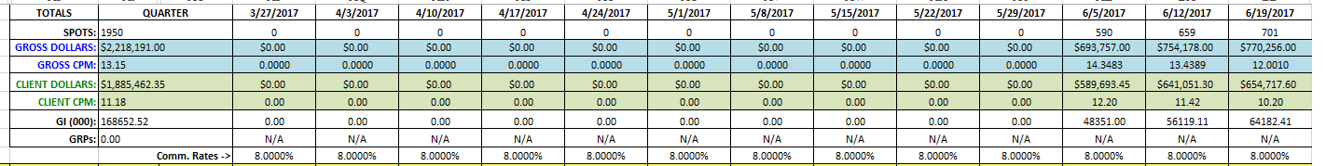

##### DataTable

Approved On:   
Approved By:   
Promised Delivery Date: 9/30/2018  
Current Status: VIEW Already coded and tested with changing commission rate but the following needs to be added: 1) Sortable Columns; 2) Multiple Filters

##### Footer

Add legend to the page

#### Create/Add Property

Approved On:   
Approved By:   
Promised Delivery Date:

Current Status:

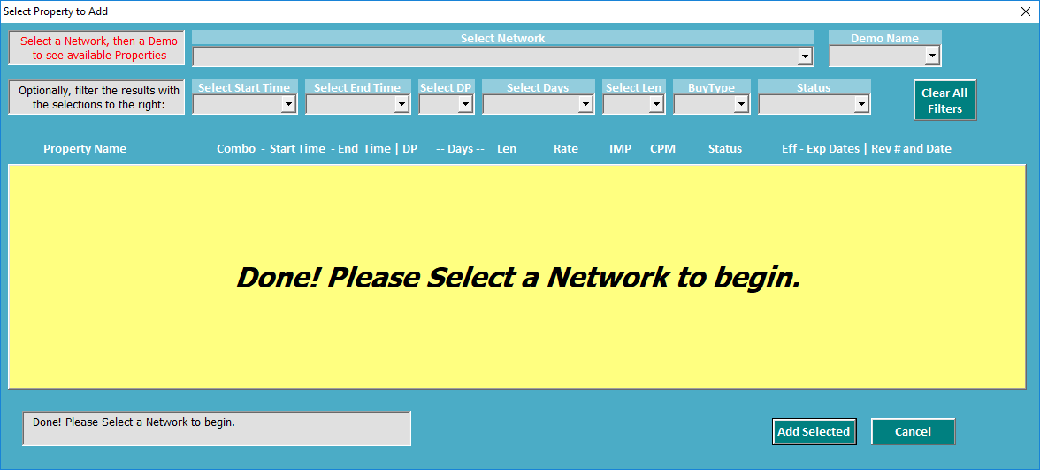

##### Networks

Initial State

* Fill with all networks for based on client and quarter of the currently opened schedule

On Change Selection

* Populate Demo Name Dropdown based on selection
* Enable Demo Name dropdown

##### Demo Name

Initial State

* Empty
* Disabled

OnChangeSelection

* Populate property list
* Populate available filters based on property list – Brenda, I will code this so that the filters are on the footer similar to Upfront/Remnant data tables

##### Select Start Time

On Initial State

* Empty
* Disabled

On Change Selection

* Filter datatable

##### Select End Time

Initial State

* Empty
* Disabled

On Change Selection

* Filter

##### Select DP

Initial State

* Empty
* Disabled

On Change Selection

* Filter

##### Select Days

Initial State

* Empty
* Disabled

On Change Selection

* Filter

##### Select Len

Initial State

* Empty
* Disabled

On Change Selection

* Filter

##### BuyType

Initial State

* Empty
* Disabled

On Change Selection

* Filter

##### Status

Initial State

* Empty
* Disabled

On Change Selection

* Filter

##### Add Selected button

1. Add Sched Line based on property checked/selected
2. Update main window

#### Copy To Schedule

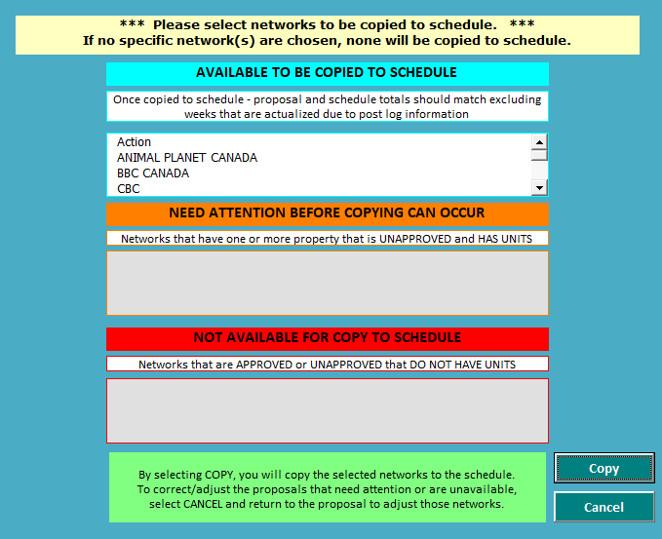

Initial State

* Only Network list is populated.

On Select Networks

* Alert user of UNAPPROVED Properties with units
* Alert user of networks that do not have units

On Copy

For each network selected, use logic from this stored procedure

exec CopyProposalToSchedByNet_SP '66651F89-A99D-4414-A019-0C42AA195B19','02CF415E-4CC9-44C6-9537-853CAB37E894','5E2E6B5D-0C88-45F2-9645-9BFB3A86BB76','Carmela Pham','376068BF-EB88-4B8C-83F2-3C39CC1CB3E3'

#### Remove Selected

Display dialog listing all lines that will be removed. Note that the lines will still be in upfront/remnant. Only the schedule line is deleted.

Those in use by a schedule, prelog or postlog cannot be deleted.

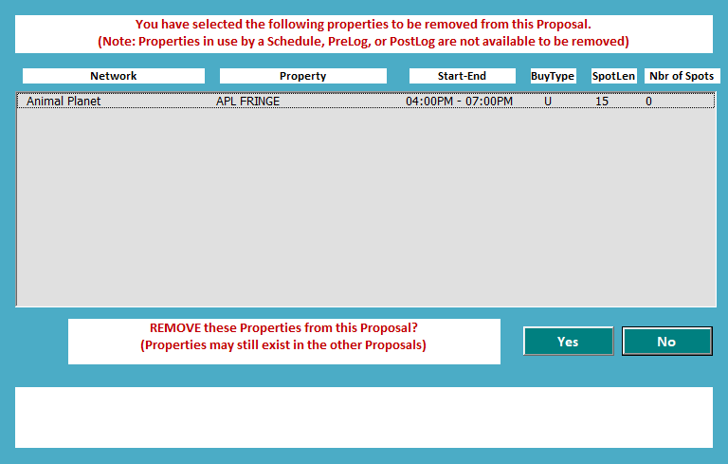

#### Reports

Keep getting many errors. Need to update my version. Ask John.

#### Add Notes

Copy interface from Upfront/Remnant. This one is for Schedule/Proposal. Only back end will be changed to reference schedule for notes that are added/edited here.

#### Show Eff/Exp Dates

Approved On:   
Approved By:   
Promised Delivery Date: 9/30/2018  
Current Status:

Hide/Show Effective and Expiration Date columns

#### Show GI Percent Breakdown

Approved On:   
Approved By:   
Promised Delivery Date: 9/30/2018  
  
Current Status:

#### Show CA/USD Dollars and CPM

Approved On:   
Approved By:   
Promised Delivery Date: 9/30/2018  
Current Status:

Calculate values based on exchange rates. This feature will only be available if proposal is not US.



#### Export

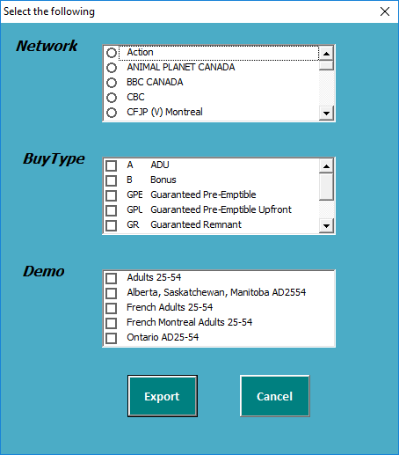

##### Network

Initial State

* Display all networks in the proposal
* None Selected

OnChangeSelection (single selection only)

* Populate Buy Type

##### Buy Type

Initial State

* Display all buy types in the proposal selected and network
* All Selected

OnChangeSelection

* Populate Demo based on buy types checked

##### Demo

Initial State

* Display all demos in the proposal selected and buy type
* All Selected

##### Export Button

Initial State

* Disabled until Demo is selected.

OnClick

UpfrontExpansionTracking needs to be implemented before we can export.

### View

Similar to EDIT but only the following are available:

* Notes
* Reports
* Show Eff/Exp Dates
* Show Percent GI Breakdown
* Show CA/USD Dollars and CPM
* Export

### Create

Only available if no proposal exists for the currently selected client/quarter.

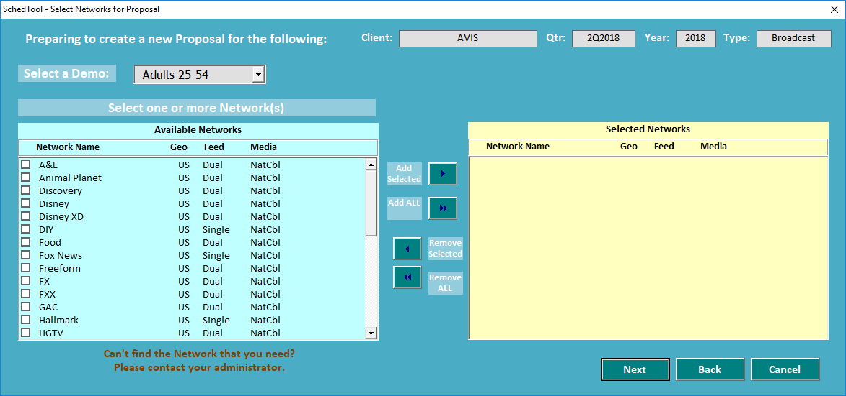

Figure . Create New Proposal

#### Client, quarter, year, type

Loaded from Network Quarter currently loaded

#### Demo

Loaded from all rates used in upfronts and remnants for the currently loaded Network/Quarter.

#### Network

Loaded based on all rates used in upfronts and remnants given the currently loaded Quarter, country, client and demo

#### Next

Go to “Step 2” of wizard on

#### Back

In the current Excel Schedule tool, this button does nothing and comes up with error. Since there is no page before the Figure 24. Create New Proposal window, we will remove this button on the first page.

#### Cancel

Closes the “Create Proposal” window

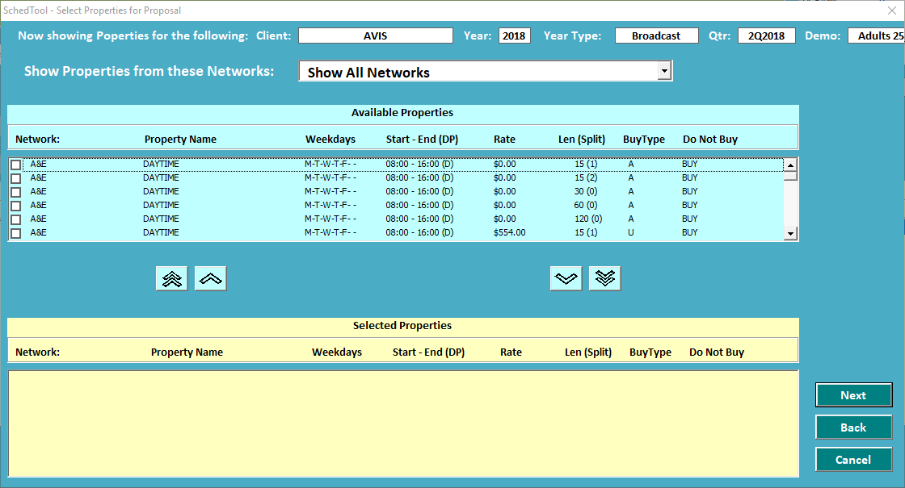

Figure . Create New Proposal (Page 2)

#### Client, Year, Type, Year Type, Demo

Load based on currently opened proposal info

#### Networks

Loaded based on all rates used in upfronts and remnants given the currently loaded Quarter, country, client and demo

#### Properties

Load all properties based on selected networks

#### Next

Go to confirmation page ()

#### Back

Close current window so that topmost window is Page 1 ()

#### Cancel

Close all windows for the “Create Proposal” wizard.

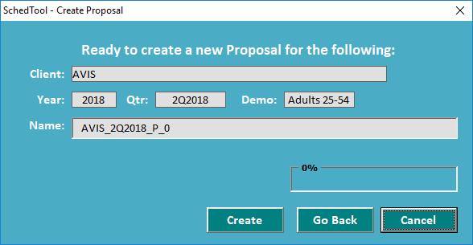

Figure . Create New Proposal – Confirm

#### Client, Year, Quarter, Demo

Populate based on user selections on previous page.

#### Name

Prepopulate with [Client Name]_[QTR]_P_n

#### CREATE button

1. Create new proposal in the SCHEDULE table
2. Create a proposal line in schedule table for each property selected.

#### GO BACK button

Close current window in the wizard

#### CANCEL button

Close all windows in the wizard

### Delete

Only available if the client/quarter open has an unlocked proposal.

### Copy to New Proposal

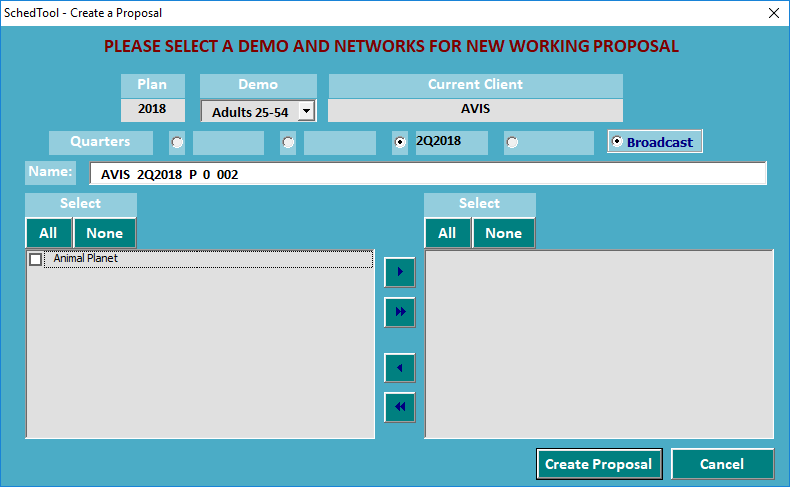

Figure . Copy To New Proposal

#### Plan

Plan year of the currently opened proposal.

#### Demo

Load demos based on quarter open

#### Client

Display name of currently open client

#### Quarter

Display name of currently open quarter

#### Name

Prepopulate with [Client]_[Quarter]_P_0_002[Create New Unique Id]. This field is editable by users.

#### network

Load all networks in the currently opened proposal and quarter.

#### Create Proposal button

1. Find a new unique ID from proposals with the same parent.
2. For each Existing Proposal which has the same Parent SchedID, check to see if any one of the Networks in the Existing Proposals match any one of the Networks in the New Proposal
3. Display Proposals with Overlapping Networks to the User
4. Copy the base Schedule from SCHED_T to create a new Working Proposal
5. Add selected Networks and Spots to newly created Working Proposal

### Display List of all Proposals

Create a flat list of all existing proposals.

## Schedule

### Edit

#### Main Screen

##### Header

Approved On:   
Approved By:   
Promised Delivery Date: 9/30/2018  
Current Status: Already Coded but need further testing. What needs to be tested is that the datatable is properly updated when the % changes

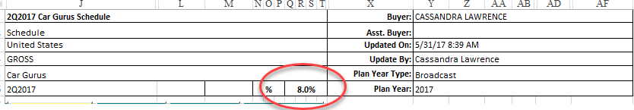

##### Summary

Approved On:   
Approved By:   
Promised Delivery Date: 9/30/2018  
PUBLISHED:   
Current Status: Already Coded but need further testing.



##### DataTable

Approved On:   
Approved By:   
Promised Delivery Date: 9/30/2018  
PUBLISHED:

Current Status: VIEW Already coded and tested with changing commission rate but the following needs to be added: 1) Sortable Columns; 2) Multiple Filters

##### Footer

Add legend to the page

#### Create/Add Property

#### Remove Selected

Display dialog listing all lines that will be removed. Note that the lines will still be in upfront/remnant. Only the schedule line is deleted.

#### Add Notes

Copy interface from Upfront/Remnant. This one is for Schedule/Proposal. Only back end will be changed to reference schedule for notes that are added/edited here.

#### Edit Actualized Week

#### Show Eff/Exp Dates

Approved On:   
Approved By:   
Promised Delivery Date: 9/30/2018  
PUBLISHED:   
Current Status:

Display Effective and Expiration Date Columns

#### Show GI Percent Breakdown

See Show GI Percent Breakdown

#### Show CA/USD Dollars and CPM

See Show CA/USD Dollars and CPM

# Appendix A. Permissions (provided by Ocean Media)

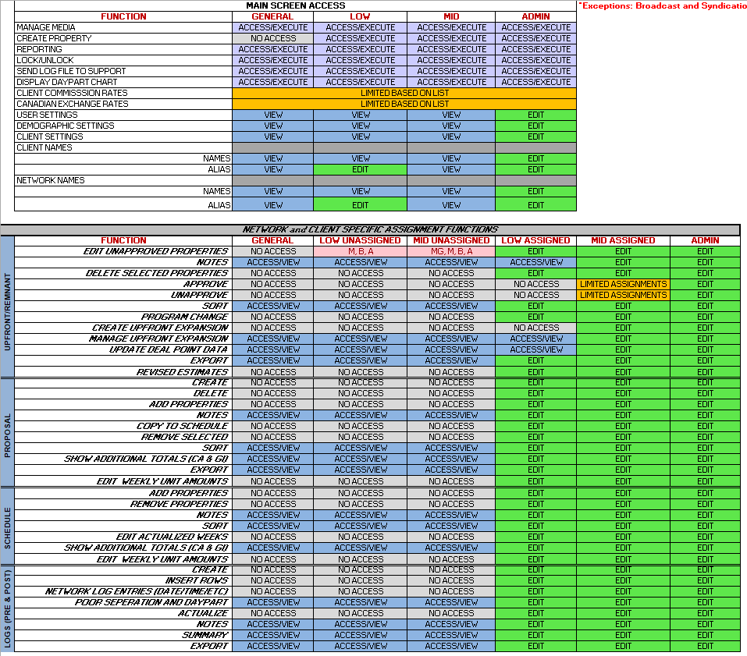

# Appendix B. Schedule

| Task | Est # of  Hours | Coding  Started | Code Completed | Dev  QA | QA | Date  Published |
| --- | --- | --- | --- | --- | --- | --- |
| NETWORK   * Add Network, Display Networks, Edit Network Name * Add Alias, Display Aliases, Delete Alias * Log Errors * Error handling and status displays * Export to Excel |  |  |  |  |  | 7/12/2018 |
| CLIENT NAMES   * Client -- Create, Read (COMPLETE), Update (COMPLETE), Delete (N/A) * Alias – Create(COMPLETE), Read (COMPLETE), Update(N/A), Delete (COMPLETE) * Log errors and actions – to be used for history viewing * Error handling and status displays |  |  |  |  |  | 7/12/2018 |
| Canadian Client Exchange Rate | 6 | 7/26/18 | 7/26/18 |  |  | 7/31/2018 |
|  |  |  |  |  |  |  |
| Client Commission Rates | 2 | N/A | N/A | N/A | N/A | 8/31/2018 |
| Log Export |  |  |  |  |  | 8/31/2018 |
| Create New Property |  |  |  |  |  | 7/31/2018 |
| Shared Between all 4 modules (Proposal, Schedule, Upfront, Remnant)   * Color Codes (Proposal/Schedule complete. Still have to apply color codes to Upfront/Remnant) * Column closing and expanding * Filter (Multiple filter selection) | 24h | 7/18/2018 |  |  |  |  |
| Upfronts |  |  |  |  |  |  |
| * Edit Upfront |  |  |  |  |  |  |
| * + Save Changes |  |  |  |  |  | 8/31/2018 |
| * + Create Property | 8 |  |  |  |  | 8/31/2018 |
| * + Add/Edit Notes |  | 7/18/2018 | 7/18/2018 |  |  | 8/31/2018 |
| * + Delete Property | 2 | 7/18/2018 | 7/18/2018 |  |  | 8/31/2018 |
| * + Approve | 4 | 7/18/2018 |  |  |  | 8/31/2018 |
| * + Unapprove | 8 | 7/18/2018 |  |  |  | 8/31/2018 |
| * + Program Change | 16 | 7/18/2018 |  |  |  | 8/31/2018 |
| * + Create Upfront Expansion | N/A | N/A | N/A | N/A | N/A | N/A |
| * + Manager Upfront Expansion | N/A | N/A | N/A | N/A | N/A | N/A |
| * + Update Deal Point Data | 2 | 7/18/2018 |  |  |  | 8/31/2018 |
| * + Export | 8 | 7/18/2018 |  |  |  | 8/31/2018 |
| * + Permissions |  |  |  |  |  | 8/31/2018 |
| * View Upfront | 2 |  |  |  |  | 8/31/2018 |
| * Display All Upfronts | 0 | 7/18/2018 | 7/18/2018 |  |  | 8/31/2018 |
| Remnants |  |  |  |  |  |  |
| * Edit Remnant |  |  |  |  |  | 8/31/2018 |
| * + Save Changes[5] |  |  |  |  |  | 8/31/2018 |
| * + Create Property [6] | 2 |  |  |  |  | 8/31/2018 |
| * + Add/Edit Notes [7] | 0 | 7/18/2018 | 7/18/2018 |  |  | 8/31/2018 |
| * + Delete Property | 2 | 7/18/2018 | 7/18/2018 |  |  | 8/31/2018 |
| * + Approve | 1 | 7/18/2018 |  |  |  | 8/31/2018 |
| * + Unapprove | 1 | 7/18/2018 |  |  |  | 8/31/2018 |
| * + Program Change [8] | 0 | N/A | N/A | N/A | N/A | 8/31/2018 |
| * + Revised Estimates | 16 |  |  |  |  |  |
| * + Update Deal Point Data | 2 | 7/18/2018 |  |  |  | 8/31/2018 |
| * + Auto Approve | 16 |  |  |  |  |  |
| * + DR Rate Revision | 8 |  |  |  |  |  |
| * + Export | 0 | N/A | N/A | N/A | N/A | 8/31/2018 |
| * + Permissions |  |  |  |  |  | 8/31/2018 |
| * View Remnant | 0 |  |  |  |  | 8/31/2018 |
| * Create Remnant | 1 |  |  |  |  | 8/31/2018 |
| * Delete Remnant | 1 |  |  |  |  | 8/31/2018 |
| * Display All Remnants | 1 |  | 7/18/2018 |  |  | 8/31/2018 |
| Schedule |  |  |  |  |  |  |
| * Edit |  |  |  |  |  |  |
| * + Main Spreadsheet |  |  |  |  |  |  |
| * + Summary |  |  |  |  |  |  |
| * + Header |  |  |  |  |  |  |
| * Edit/View Schedule   + - Main Spreadsheet     - Summary     - Header     - Add Properties     - Remove Selected     - Notes     - Sort     - Edit Actualized Weeks     - Show Eff/Exp Dates     - Show Percent GI Breakdown     - Show CA/USD/Dllars and CPMs * Delete Schedule * Copy to Proposal * Display List of All Schedule |  |  |  |  |  |  |
| Proposal |  |  |  |  |  |  |
| * + Edit/View Proposal     - Main Spreadsheet (QA Only)     - Summary (QA Only)CAS     - Header (QA Only)     - Add Property     - Notes     - Copy To Schedule     - Remove Selected     - Show Eff/Exp Dates     - Show Percent GI Breakdown     - Show CAD/USD Dollars and CPMs     - Export   + Create Proposal   + Delete Proposal   + Copy to New Proposal |  |  |  |  |  |  |

1. Buy types can only be changed for Unapproved lines?
2. This check does not seem necessary to me but in case there are scenarios I haven’t considered, I kept this check here which is from the original code.
3. This code will be used for data tables for Upfronts, Remnants, Schedules and Proposals
4. User cannot access any part of the upfront screen while in Program Change. Upfront screen will be in the background and dimmed.
5. Shared code with Upfront.
6. Shared code with Upfront but added additional time for testing different scenarios and testing on a different web page.
7. Shared code with Upfront. Not anticipating additional testing time due to code being used exactly the same on both web pages.
8. Shared code with Upfront. Not anticipating additional testing time due to code being used exactly same on both web pages.